**Institut Sains Terapan dan Teknologi Surabaya**

Jl. Ngagel Jaya Tengah 73 - 77, Surabaya 60284

Telp. (031) 5027920 Fax. (031) 5041509

Laboratorium : E-401 Praktikum : Pemrograman Client Server

Waktu : Senin / 10.45 – 12.45 Jurusan : S1 – Teknik Informatika

Minggu Ke : 5 Tanggal : -

Materi : Master Jenis Soal : Materi dan Tugas

**MATERI (TOTAL = 40)**

Buatlah sebuah master player pada database yang meliputi CRUD (Create, Read, Update, Delete) dan memiliki fitur search.

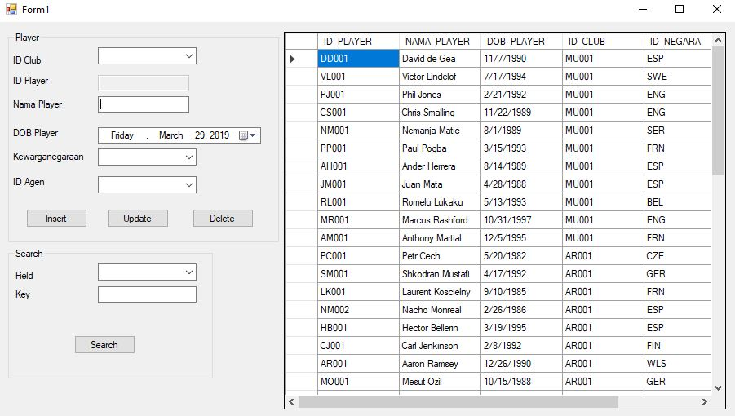

Komponen CRUD Player terdiri dari

* Dropdown ID Club yang menyediakan pilihan untuk semua id club yang terdaftar pada database
* Textbox ID Player yang tidak bisa di edit secara manual, namun akan autogenerate setiap kali user mengetik pada Textbox Nama Player. ID yang digenerate menggunakan aturan :

Jika nama player terdiri 1 kata, kode = 2huruf pertama nama + 3 digit urutan

Jika nama player terdiri lebih dari 1 kata, kode = 1huruf kata pertama + 1 huruf kata terakhir+3 digit urutan

* Textbox Nama Player yang digunakan untuk mengisi nama player yang akan diinput
* DateTimePicker yang digunakan untuk mengisi tanggal lahir player yang akan diinput
* Dropdown Kewarganegaraan yang berisi semua **ID NEGARA** yang tersedia
* Dropdown ID AGEN yang berisi semua **ID AGEN** yang tersedia
* Button Insert, Button Update, dan Button Delete
* Data Grid View untuk menampilkan data semua player atau menampilkan data hasil search

Komponen Search

* Dropdown field yang akan berisi

1. ID Player

2. Nama Player

Dropdown tersebut digunakan untuk melakukan pencarian berdasarkan nilai dropdown yang dipilih

* Textbox key akan berisi keyword yang akan dicari.
* Button Search yang jika ditekan akan melakukan pencarian. Pencarian yang dilakukan akan bersifat %LIKE%.

Fitur Tambahan

* Apabila suatu row pada data grid view diklik, maka data player yang berada pada row tersebut akan muncul pada groupbox Player.
* Terdapat fitur untuk mengupdate. Pada saat row ditekan, maka setelah data berpindah, akan memasuki edit mode. Dimana user dapat mengupdate dan melakukan delete. Pada edit mode, id player tidak akan berubah walaupun nama diubah. Untuk keluar dari edit mode, maka tombol insert akan ditekan 1x untuk keluar dari edit mode.

**Catatan : Pengerjaan harus dilakukan dengan sempurna, termasuk header. Jika header kolom berbeda atau urutan data tidak sama dengan contoh, maka jawaban pada nomor yang bersangkutan akan di**

**div 2!**

**MATERI : 40**

|  |  |
| --- | --- |
| SCORE | KRITERIA |
| Insert | |
| 2/0 | Tampilan sesuai |
| 3/0 | Dapat menampilkan data pada datagridview |
| 6/3/1/0 | Dapat mengisi Combobox id_club, id_negara dan id_agen dengan baik |
| 5/0 | Dapat Melakukan insert pada data player |
| 5/0 | Dapat menampilkan data yang di klik pada form |
| 7/3/0 | Dapat melakukan update pada data  2 : jika tidak dapat melakukan update pada nama |
| 5/0 | Dapat melakukan delete pada data |
| 7/0 | Dapat melakukan search dengan baik untuk setiap field yang tersedia (id_player dan nama_player) yang bersifat like |
| Total : 40 | |

**TUGAS : 30**

**UNTUK AUTORISASI DATABASE, GUNAKAN USER ‘n217116657’ dan password ‘217116657’**

Buatlah sistem master untuk personnel dan club

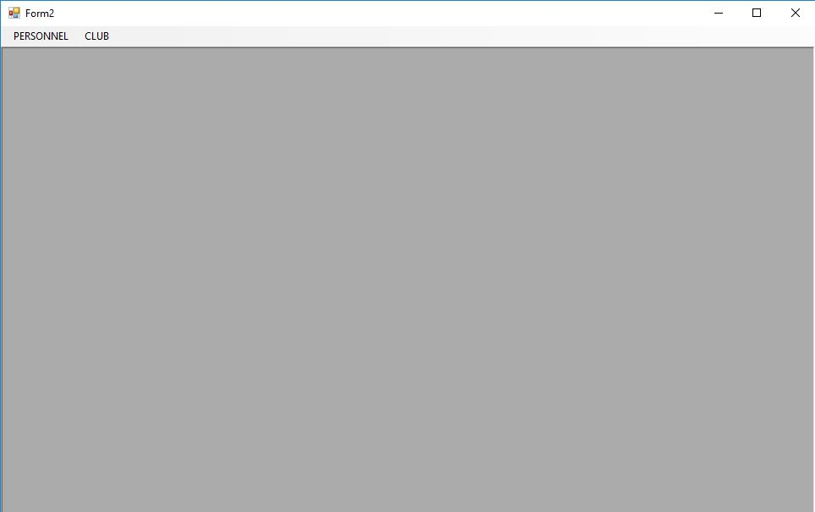

Pada form awal terdapat 2 menu untuk membuka master personnel atau master club. Jika menu Personnel diklik maka buatlah menu personel menjadi disabled. Jika menu club di klik, maka personnel kembali menjadi enabled dan club juga akan menjadi disabled.

1. Master Personnel

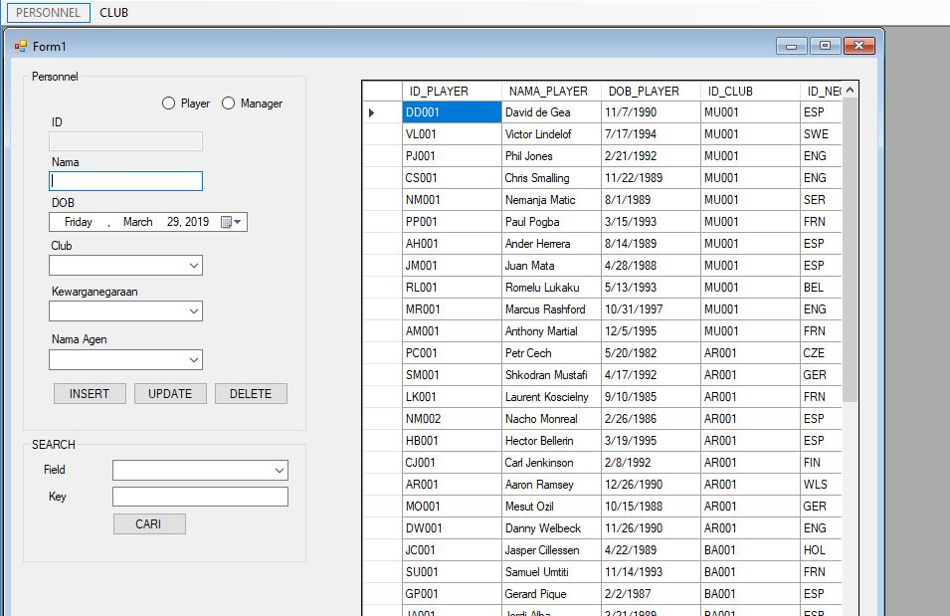

* Buatlah master personnel untuk dapat memanipulasi data player dan manager
* Apabila radio button player aktif/dipilih maka akan menjadi mode player, bila manager dipilih maka akan menjadi mode manager
* Textbox ID akan berstatus disabled.
* Textbox nama akan berisi nama personnel. Apabila dalam mode master player, maka id yang di autogenerate akan berdasarkan peraturan generate id player pada materi. Jika dalam mode manager, maka buatlah autogenerate id manager dengan format “MAN”+3 digit urutan.
* DateTimePicker digunakan untuk memilih DOB.
* Combobox Club akan berisi **NAMA CLUB** yang tersedia.
* Combobox kewarganegaraan akan berisi **NAMA NEGARA**  yang tersedia.
* Combobox nama agen akan berisi **NAMA AGEN** yang tersedia.
* Apabila row pada datagridview di klik, maka data akan berpindah ke form. Pada bagian combobox, yang harus ditampilkan adalah nama, bukan id.
* Operasi tombol insert, update, delete sama seperti materi. Demikian pula dengan bagian search
* **Perlu diperhatikan bahwa setiap dari player dan manager harus memiliki club tujuan**

1. Master Club

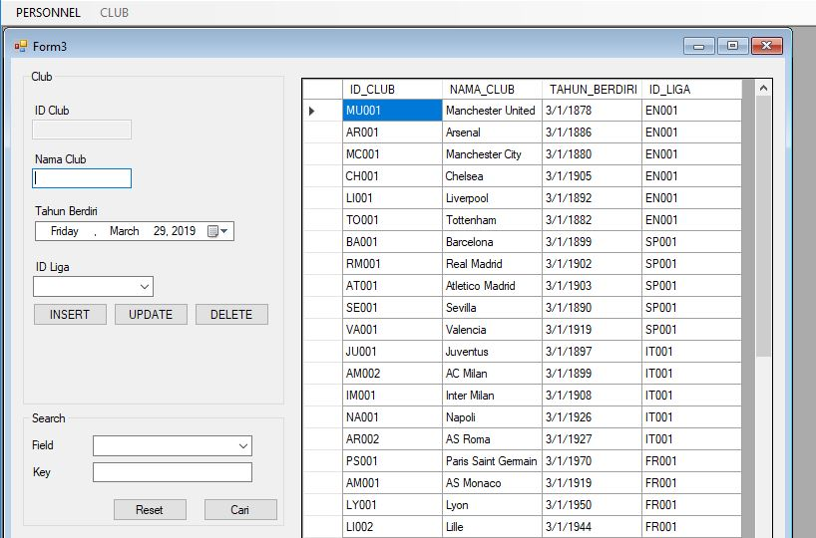

* Buatlah master club yang dapat melakukan Operasi CRUD (Create, Read, Update, Delete)
* Textbox ID akan berada dalam status disabled. Format id club yang akan di generate adalah 1 huruf kata awal, + 1 huruf kata akhir + 3 digit urutan untuk club yang namanya lebih dari 1 kata. Untuk club yang memiliki nama hanya 1 kata, maka menggunakan format 2 huruf awal+3 digit urutan.
* Textbox Nama akan diisi dengan nama club
* DateTimePicker akan menghasilkan tahun berdiri club
* ID Liga akan berisi daftar id liga yang terdaftar pada database
* Search akan berjalan sesuai dengan master personnel

**Catatan : Pengerjaan harus dilakukan dengan sempurna, termasuk header. Jika header kolom berbeda atau urutan data tidak sama dengan contoh, maka jawaban pada nomor yang bersangkutan akan dinilai 0!**

**KRITERIA YANG TIDAK DI HIGHLIGHT TIDAK AKAN DIPERIKSA**

|  |  |
| --- | --- |
| SCORE | KRITERIA |
| 3/0 | Tampilan Sesuai untuk ketiga form dan form-form berjalan dengan baik. |
| 3/0 | Dapat melakukan insert pada master personnel (radiobutton harus bekerja dengan baik) |
| 3/0 | Dapat melakukan update pada master personnel (radiobutton harus bekerja dengan baik dan harus dapat update nama tanpa mengubah id) dan dapat melakukan **operasi delete** |
| Untuk kriteria INSERT, UPDATE, DELETE diatas harus bekerja pada master player dan manager | |
| 3/0 | Dapat memindahkan data sesuai ketentuan dari datagridview ke masing-masing form |
| 3/0 | Dapat melakukan search pada master personnel berdasarkan radiobutton |
| 3/0 | Dapat melakukan insert pada master club |
| 3/0 | Dapat melakukan update pada master club dan dapat melakukan delete pada master club |
| 3/0 | Dapat melakukan delete pada master club |
| 3/0 | Dapat melakukan search pada table club. |
| 3/0 | Dapat menampilkan data pada datagridview form master player, manager (radio button haru bekerja dengan baik), dan club |
| Total : 30 | |

Menyetujui Mengetahui Penyusun Soal

(Riandika Lumaris, S.Kom., M.Kom.) (Grace Levina Dewi, M.Kom.) (Kenny Vincent)

Koordinator Kuliah Koordinator Laboratorium Asisten

|  |  |
| --- | --- |
| Negara | |
| column | type |
| id_negara | Varchar2(3), PK |
| Nama_negara | Varchar2(15) |

|  |  |
| --- | --- |
| Liga | |
| column | type |
| id_liga | Varchar2(5), PK |
| Nama_liga | Varchar2(30) |
| Id_negara | Varchar2(3), references negara(id_negara) |
| divisi | number |

|  |  |
| --- | --- |
| Agen | |
| column | type |
| id_agen | Varchar2(7), PK |
| Nama_agen | Varchar2(20) |
| experience | Number |
| Id_negara | Varchar2(3), references negara(id_negara) |

|  |  |
| --- | --- |
| Manager | |
| column | type |
| id_manager | Varchar2(6), PK |
| Nama_manager | Varchar2(20) |
| Dob_manager | date |
| Id_negara | Varchar2(3), references negara(id_negara) |
| Id_agen | Varchar2(7), references agen(id_agen) |

|  |  |
| --- | --- |
| Club | |
| column | type |
| id_club | Varchar2(7), PK |
| Nama_club | Varchar2(20) |
| Tahun_berdiri | date |
| Id_liga | Varchar2(5), references liga(id_liga) |

|  |  |
| --- | --- |
| Stadium | |
| column | type |
| id_stadium | Varchar2(6), PK |
| Nama_stadium | Varchar2(20) |
| Kapasitas | Number |
| Id_club | Varchar2(7), references club(id_club) |
| Id_negara | Varchar2(3), references negara(id_negara) |

|  |  |
| --- | --- |
| Player | |
| column | type |
| id_player | Varchar2(8), PK |
| Nama_player | Varchar2(20) |
| Dob_player | Date |
| Id_club | Varchar2(7), references club(id_club) |
| Id_negara | Varchar2(3), references negara(id_negara) |
| Id_agen | Varchar2(3), references agen(id_agen) |

|  |  |
| --- | --- |
| H_transaksi | |
| column | type |
| id_transaksi | Varchar2(8), PK |
| Club_asal | Varchar2(7), references club(id_club) |
| Club_baru | Varchar2(7), references club(id_club) |
| Biaya_transfer | Number |
| Tgl_transfer | Date |

|  |  |
| --- | --- |
| D_transaksi | |
| column | type |
| id_transaksi | Varchar2(8), PK |
| Id_player | Varchar2(8), references player(id_player), PK |
| Subtotal | Number |

|  |  |
| --- | --- |
| Club_Manager | |
| column | type |
| id_club | Varchar2(7), references club(id_club), PK |
| Id_manager | Varchar2(6), references manager(id_manager), PK |

|  |  |
| --- | --- |
| Negara | |
| id_negara | nama_negara |
| ENG | ENGLAND |
| FRN | FRANCE |
| ESP | SPAIN |
| WLS | WALES |
| GER | GERMANY |
| ITA | ITALY |
| JPN | JAPAN |
| ROM | ROMANIA |
| RUS | RUSSIA |
| UKR | UKRAINE |
| BEL | BELGIUM |
| HOL | HOLLAND |
| USA | USA |
| SWE | SWEDEN |
| NOR | NORWAY |
| CRO | CROATIA |
| ICE | ICELAND |
| DEN | DENMARK |
| CZE | CZECH |
| IRE | IRELAND |
| FIN | FINLAND |
| BUL | BULGARIA |
| SER | SERBIA |
| KOR | SOUTH KOREA |
| ARG | ARGENTINA |
| BRA | BRAZIL |
| POR | PORTUGAL |
| SCO | SCOTLAND |

|  |  |  |  |
| --- | --- | --- | --- |
| Liga | | | |
| id_liga | nama_liga | id_negara | divis |
| EN001 | Premier League | ENG | 1 |
| EN002 | EFL Championship | ENG | 2 |
| EN003 | English Football League | ENG | 3 |
| EN004 | EFL League One | ENG | 4 |
| EN005 | EFL League Two | ENG | 5 |
| EN006 | National League (division) | ENG | 6 |
| FR001 | [Ligue 1](https://en.wikipedia.org/wiki/Ligue_1) | FRN | 1 |
| FR002 | [Ligue 2](https://en.wikipedia.org/wiki/Ligue_2) | FRN | 2 |
| FR003 | [Championnat National](https://en.wikipedia.org/wiki/Championnat_National) | FRN | 3 |
| FR004 | [Championnat National 2](https://en.wikipedia.org/wiki/Championnat_National_2) | FRN | 4 |
| FR005 | [Championnat National 3](https://en.wikipedia.org/wiki/Championnat_National_3) | FRN | 5 |
| SP001 | [La Liga](https://en.wikipedia.org/wiki/La_Liga) | ESP | 1 |
| SP002 | [Segunda División](https://en.wikipedia.org/wiki/Segunda_Divisi%C3%B3n) | ESP | 2 |
| SP003 | [Segunda División B](https://en.wikipedia.org/wiki/Segunda_Divisi%C3%B3n_B) | ESP | 3 |
| SP004 | [Tercera División](https://en.wikipedia.org/wiki/Tercera_Divisi%C3%B3n) | ESP | 4 |
| SP005 | [Divisiones Regionales](https://en.wikipedia.org/wiki/Divisiones_Regionales_de_F%C3%BAtbol) | ESP | 5 |
| IT001 | [Serie A](https://en.wikipedia.org/wiki/Serie_A) | ITA | 1 |
| IT002 | [Serie B](https://en.wikipedia.org/wiki/Serie_B) | ITA | 2 |
| IT003 | [Serie C](https://en.wikipedia.org/wiki/Serie_C) | ITA | 3 |
| IT004 | [Serie D](https://en.wikipedia.org/wiki/Serie_D) | ITA | 4 |
| IT005 | [Eccellenza](https://en.wikipedia.org/wiki/Eccellenza) | ITA | 5 |
| IT006 | [Promozione](https://en.wikipedia.org/wiki/Promozione) | ITA | 6 |
| HO001 | Eredvisie | HOL | 1 |
| BA001 | Campeonato Serie A | BRA | 1 |
| AR001 | Superliga Argentina | ARG | 1 |
| US001 | Major League Soccer | USA | 1 |
| JP001 | Japan League | JPN | 1 |
| KO001 | Korea League | KOR | 1 |
| BE001 | Belgian First Division A | BEL | 1 |

|  |  |  |  |
| --- | --- | --- | --- |
| Club | | | |
| Id_club | Nama_club | tahun_berdiri | Id_liga |
| MU001 | Manchester United | 1878 | EN001 |
| AR001 | Arsenal | 1886 | EN001 |
| MC001 | Manchester City | 1880 | EN001 |
| CH001 | Chelsea | 1905 | EN001 |
| LI001 | Liverpool | 1892 | EN001 |
| TO001 | Tottenham | 1882 | EN001 |
| BA001 | Barcelona | 1899 | SP001 |
| RM001 | Real Madrid | 1902 | SP001 |
| AT001 | Atletico Madrid | 1903 | SP001 |
| SE001 | Sevilla | 1890 | SP001 |
| VA001 | Valencia | 1919 | SP001 |
| JU001 | Juventus | 1897 | IT001 |
| AM002 | AC Milan | 1899 | IT001 |
| IM001 | Inter Milan | 1908 | IT001 |
| NA001 | Napoli | 1926 | IT001 |
| AR002 | AS Roma | 1927 | IT001 |
| PS001 | Paris Saint Germain | 1970 | FR001 |
| AM001 | AS Monaco | 1919 | FR001 |
| LY001 | Lyon | 1950 | FR001 |
| LI002 | Lille | 1944 | FR001 |
| MA001 | Marseille | 1899 | FR001 |
| SA001 | Santos | 1912 | BA001 |
| SP001 | Sao Paulo | 1930 | BA001 |
| FL001 | Flamengo | 1895 | BA001 |
| IN001 | Internacional | 1909 | BA001 |
| GR001 | Gremio | 1903 | BA001 |
| BJ001 | Boca Junior | 1905 | AR001 |
| RP001 | River Plate | 1901 | AR001 |
| IN002 | Independiate | 1958 | AR001 |
| RC001 | Racing Club | 1903 | AR001 |
| GO001 | Gamba Osaka | 1980 | JP001 |
| FT001 | FC Tokyo | 1935 | JP001 |
| CO001 | Cerezo Osaka | 1957 | JP001 |
| VK001 | Vissel Kobe | 1966 | JP001 |
| UR001 | Urawa Reds | 1950 | JP001 |
| YF001 | Yokohama FM | 1972 | JP001 |
| GE001 | Genk | 1923 | BE001 |
| CB001 | Club Brugge | 1891 | BE001 |
| AN001 | Anderlecht | 1908 | BE001 |
| AV001 | [Aston Villa](http://www.bbc.co.uk/sport/football/teams/aston-villa) | 1910 | EN002 |
| BC001 | [Birmingham City](http://www.bbc.co.uk/sport/football/teams/birmingham-city) | 1912 | EN002 |
| BR001 | [Blackburn Rovers](http://www.bbc.co.uk/sport/football/teams/blackburn-rovers) | 1914 | EN002 |
| BW001 | [Bolton Wanderers](http://www.bbc.co.uk/sport/football/teams/bolton-wanderers) | 1916 | EN002 |
| BR002 | [Brentford](http://www.bbc.co.uk/sport/football/teams/brentford) | 1918 | EN002 |
| BC002 | [Bristol City](http://www.bbc.co.uk/sport/football/teams/bristol-city) | 1919 | EN002 |
| AW001 | [AFC Wimbledon](http://www.bbc.co.uk/sport/football/teams/afc-wimbledon) | 1921 | EN003 |
| AS001 | [Accrington Stanley](http://www.bbc.co.uk/sport/football/teams/accrington-stanley) | 1923 | EN003 |
| BA002 | [Barnsley](http://www.bbc.co.uk/sport/football/teams/barnsley) | 1925 | EN003 |
| BL001 | [Blackpool](http://www.bbc.co.uk/sport/football/teams/blackpool) | 1927 | EN003 |
| BC003 | [Bradford City](http://www.bbc.co.uk/sport/football/teams/bradford-city) | 1929 | EN003 |
| BR003 | [Bristol Rovers](http://www.bbc.co.uk/sport/football/teams/bristol-rovers) | 1922 | EN003 |
| EV001 | [Everton](http://www.bbc.co.uk/sport/football/teams/bristol-rovers) | 1910 | EN001 |

|  |  |  |  |  |
| --- | --- | --- | --- | --- |
| Stadium | | | | |
| id_stadium | nama_stadium | kapasitas | id_club | id_negara |
| STD001 | Gavea Stadium | 78838 | FL001 | ENG |
| STD002 | Bloomfield Rd | 16220 | BL001 | ENG |
| STD003 | Old Trafford | 74643 | MU001 | ENG |
| STD004 | City of Manchester | 55097 | MC001 | ENG |
| STD005 | Stamford Bridge | 41631 | CH001 | ENG |
| STD006 | Anfield | 54074 | LI001 | ENG |
| STD007 | White Hart Lane | 36284 | TO001 | ENG |
| STD008 | Camp Nou | 99354 | BA001 | ESP |
| STD009 | Santiago Barnabeu | 81044 | RM001 | ESP |
| STD010 | Wanda Metropolitano | 68000 | AM002 | ESP |
| STD011 | Pizjuan Stadium | 43883 | SE001 | ESP |
| STD012 | Mestalla Stadium | 49500 | VA001 | ESP |
| STD013 | Juventus Stadium | 41507 | JU001 | ITA |
| STD014 | San Siro | 36500 | AM002 | ITA |
| STD015 | Guiseppe Meazza | 37000 | IM001 | ITA |
| STD016 | Stadio San Paolo | 60240 | NA001 | ITA |
| STD017 | Stadio Olimpico | 72900 | AR002 | ITA |
| STD018 | Parc des Princes | 47900 | PS001 | FRN |
| STD019 | Kincho Stadium | 18000 | CO001 | JPN |
| STD020 | Noevir Stadium | 30134 | VK001 | JPN |
| STD021 | Saitama Stadium | 63700 | UR001 | JPN |
| STD022 | Nissan Stadium | 72327 | YF001 | JPN |
| STD023 | Luminus Arena | 23718 | GE001 | BEL |
| STD024 | Jan Breydel | 29062 | CB001 | BEL |
| STD025 | Vanden Stock | 21500 | AN001 | BEL |
| STD026 | Villa Park | 42682 | AV001 | [ENG](http://www.bbc.co.uk/sport/football/teams/aston-villa) |
| STD027 | St Andrew's | 29409 | BC001 | [ENG](http://www.bbc.co.uk/sport/football/teams/birmingham-city) |
| STD028 | Ewood Park | 31367 | BR001 | [ENG](http://www.bbc.co.uk/sport/football/teams/blackburn-rovers) |

|  |  |  |  |
| --- | --- | --- | --- |
| Agen | | | |
| id_agen | nama_agen | exp (years) | id_negara |
| AGEN001 | Lee Philpott | 11 | ENG |
| AGEN002 | Jonathan Dean | 8 | ENG |
| AGEN003 | Chris Greenhill | 8 | ENG |
| AGEN004 | Jonny Hughes | 10 | ENG |
| AGEN005 | Graham Duffield | 2 | ENG |
| AGEN006 | Magno Vieira | 7 | ENG |
| AGEN007 | David Bosumtwe | 12 | ENG |
| AGEN008 | Adam Bouskouchi | 3 | ENG |
| AGEN009 | David Currie | 5 | ENG |
| AGEN010 | Curtis Dawes | 1 | ENG |
| AGEN011 | Frederik De Jong | 5 | ENG |
| AGEN012 | Joseph Chenwi | 2 | ENG |
| AGEN013 | Peter Bint | 4 | ENG |
| AGEN014 | Lionel Foy | 5 | ENG |
| AGEN015 | Mark Gibbon | 3 | ENG |
| AGEN016 | Diomansy Kamara | 10 | FRN |
| AGEN017 | Olusola Omole | 2 | FRN |
| AGEN018 | Sabastine Onyeka | 9 | USA |
| AGEN019 | Emmanuel Mensah | 9 | FRN |
| AGEN020 | Osman Chari | 10 | USA |
| AGEN021 | Augusto Lopez | 3 | USA |
| AGEN022 | Antti Roiha | 7 | FIN |
| AGEN023 | Razaq Raji | 11 | IRE |
| AGEN024 | Eric Darko | 10 | USA |
| AGEN025 | Alexandre Marquot | 10 | FRN |
| AGEN026 | Matthijs Lambregts | 5 | HOL |
| AGEN027 | Bo Nilsson | 0 | SWE |
| AGEN028 | Constantin Negura | 2 | ROM |
| AGEN029 | Thiery Manigone | 2 | IRE |
| AGEN030 | Adolfo Lopes | 9 | POR |

|  |  |  |  |  |
| --- | --- | --- | --- | --- |
| Manager | | | | |
| id_manager | nama_manager | DOB | id_negara | id_agen |
| MAN001 | Greg Abbot | 14-12-1963 | ENG | AGEN001 |
| MAN002 | Alex Ferguson | 31-12-1941 | SCO | AGEN002 |
| MAN003 | Arsene Wenger | 22-10-1949 | FRN | AGEN003 |
| MAN004 | Josep Guardiola | 18-01-1971 | ESP | AGEN004 |
| MAN005 | Maurizio Sarri | 10-01-1959 | ITA | AGEN005 |
| MAN006 | Jurgen Klopp | 16-06-1967 | GER | AGEN015 |
| MAN007 | Mauricio Pochettino | 02-03-1972 | ARG | AGEN016 |
| MAN008 | Ernesto Valverde | 09-02-1964 | ESP | AGEN017 |
| MAN009 | Santiago Solari | 08-10-1976 | ARG | AGEN018 |
| MAN010 | Diego Simeone | 28-04-1970 | ARG | AGEN019 |
| MAN011 | Pablo Machin | 07-04-1975 | ESP | AGEN020 |
| MAN012 | Marcelino Toral | 14-08-1965 | ESP | AGEN021 |
| MAN013 | Massimiliano Allegri | 11-08-1967 | ITA |  |
| MAN014 | Gennaro Gattuso | 09-01-1978 | ITA | AGEN021 |
| MAN015 | Luciano Spalletti | 03-07-1959 | ITA | AGEN022 |
| MAN016 | Carlo Ancelotti | 10-06-1959 | ITA | AGEN023 |
| MAN017 | Eusebio Di Francesco | 08-09-1969 | ITA |  |
| MAN018 | Thomas Tuchel | 29-08-1973 | ITA | AGEN025 |
| MAN019 | Leonardo Jardim | 01-08-1974 | POR | AGEN026 |
| MAN020 | Bruno Genesio | 01-09-1966 | FRN |  |
| MAN021 | Christophe Galtier | 23-08-1966 | FRN |  |
| MAN022 | Rudi Garcia | 20-02-1964 | FRN | AGEN011 |
| MAN023 | Fernando Santos | 10-10-1954 | POR |  |
| MAN024 | Carlos Parreira | 27-02-1943 | BRA | AGEN013 |
| MAN025 | Abel Braga | 09-01-1952 | BRA | AGEN014 |
| MAN026 | Renato Portaluppi | 09-09-1962 | BRA | AGEN015 |
| MAN027 | Gustavo Alfaro | 14-08-1962 | ARG | AGEN013 |
| MAN028 | Marcelo Gallardo | 18-01-1976 | ARG | AGEN014 |
| MAN029 | Tsuneyasu Miyamoto | 07-02-1997 | JPN |  |
| MAN030 | Jose Mourinho | 26-01-1963 | POR | AGEN016 |
| MAN031 | Zinedine Zidane | 23-06-1972 | FRN | AGEN017 |
| MAN032 | Paolo Maldini | 26-06-1968 | ITA | AGEN018 |
| MAN033 | Harry Redknapp | 02-03-1947 | ENG |  |
| MAN034 | Kenny Dalglish | 04-03-1951 | SCO | AGEN020 |

|  |  |  |  |  |  |
| --- | --- | --- | --- | --- | --- |
| Player | | | | | |
| id_player | nama_player | DOB | id_club | id_negara | id_agen |
| DD001 | David de Gea | 07-11-1990 | MU001 | ESP | AGEN020 |
| VL001 | Victor Lindelof | 17-07-1994 | MU001 | SWE | AGEN021 |
| PJ001 | Phil Jones | 21-02-1992 | MU001 | ENG | AGEN022 |
| CS001 | Chris Smalling | 22-11-1989 | MU001 | ENG | AGEN023 |
| NM001 | Nemanja Matic | 01-08-1989 | MU001 | SER | AGEN008 |
| PP001 | Paul Pogba | 15-03-1993 | MU001 | FRN | AGEN009 |
| AH001 | Ander Herrera | 14-08-1989 | MU001 | ESP | AGEN010 |
| JM001 | Juan Mata | 28-04-1988 | MU001 | ESP | AGEN011 |
| RL001 | Romelu Lukaku | 13-05-1993 | MU001 | BEL | AGEN012 |
| MR001 | Marcus Rashford | 31-10-1997 | MU001 | ENG | AGEN001 |
| AM001 | Anthony Martial | 05-12-1995 | MU001 | FRN | AGEN002 |
| PC001 | Petr Cech | 20-05-1982 | AR001 | CZE | AGEN003 |
| SM001 | Shkodran Mustafi | 17-04-1992 | AR001 | GER | AGEN004 |
| LK001 | Laurent Koscielny | 10-09-1985 | AR001 | FRN | AGEN005 |
| NM002 | Nacho Monreal | 26-02-1986 | AR001 | ESP | AGEN006 |
| HB001 | Hector Bellerin | 19-03-1995 | AR001 | ESP | AGEN004 |
| CJ001 | Carl Jenkinson | 08-02-1992 | AR001 | FIN | AGEN005 |
| AR001 | Aaron Ramsey | 26-12-1990 | AR001 | WLS | AGEN006 |
| MO001 | Mesut Ozil | 15-10-1988 | AR001 | GER | AGEN007 |
| DW001 | Danny Welbeck | 26-11-1990 | AR001 | ENG | AGEN008 |
| JC001 | Jasper Cillessen | 22-04-1989 | BA001 | HOL | AGEN009 |
| SU001 | Samuel Umtiti | 14-11-1993 | BA001 | FRN | AGEN010 |
| GP001 | Gerard Pique | 02-02-1987 | BA001 | ESP | AGEN011 |
| JA001 | Jordi Alba | 21-03-1989 | BA001 | ESP | AGEN022 |
| NS001 | Nelson Semedo | 16-11-1993 | BA001 | POR | AGEN023 |
| PC002 | Philippe Countinho | 12-06-1992 | BA001 | BRA | AGEN024 |
| OD001 | Ousmane Dembele | 15-05-1997 | BA001 | FRN | AGEN025 |
| LM001 | Lionel Messi | 24-06-1987 | BA001 | ARG | AGEN026 |
| SB001 | Sergio Busquets | 16-07-1988 | BA001 | ESP | AGEN027 |
| FL001 | Filipe Luis | 09-08-1985 | AT001 | BRA | AGEN028 |
| JU001 | Juanfran | 09-01-1985 | AT001 | ESP | AGEN029 |
| KO001 | Koke | 08-01-1992 | AT001 | ESP | AGEN030 |
| VI001 | Vitolo | 02-11-1989 | AT001 | ESP | AGEN015 |
| AG001 | Antoine Griezmann | 21-03-1991 | AT001 | FRN | AGEN016 |
| DC001 | Diego Costa | 07-10-1988 | AT001 | ESP | AGEN017 |
| PD001 | Paulo Dybala | 15-11-1993 | JU001 | ARG | AGEN018 |
| CR001 | Cristiano Ronaldo | 05-02-1985 | JU001 | POR | AGEN019 |
| MM001 | Mario Mandzukic | 21-05-1986 | JU001 | CRO | AGEN027 |
| LM002 | Luka Modric | 09-09-1985 | RM001 | CRO | AGEN028 |
| AD001 | Angel Di Maria | 14-02-1988 | PS001 | ARG | AGEN020 |
| KM001 | Kylian Mbappe | 20-12-1998 | PS001 | FRN | AGEN022 |
| NE001 | Neymar | 05-02-1992 | PS001 | BRA | AGEN023 |
| HK001 | Hiroshi Kiyotake | 12-11-1989 | CO001 | JPN | AGEN024 |
| YM001 | Yusuke Maruhasi | 02-09-1990 | CO001 | JPN | AGEN025 |
| MI001 | Mauri Icardi | 19-02-1993 | IM001 | ARG | AGEN026 |
| LI001 | Lorenzo Insigne | 04-06-1991 | NA001 | ITA | AGEN027 |
| JP001 | Javier Pastore | 20-06-1989 | AR002 | ARG | AGEN028 |
| DA001 | Dani Alves | 06-05-1983 | PS001 | BRA | AGEN029 |
| IR001 | Ivan Rakitic | 10-03-1998 | BA001 | CRO | AGEN030 |

|  |  |  |  |  |
| --- | --- | --- | --- | --- |
| Transaksi | | | | |
| id_transaksi | club_asal | club_baru | biaya_transfer | tgl_transfer |
| TRANS001 | EV001 | MU001 | 50000000 | 10-07-2017 |
| TRANS002 | JU001 | MU001 | 70000000 | 09-08-2016 |
| TRANS003 | AM001 | MU001 | 20000000 | 09-08-2017 |
| TRANS004 | NA001 | PS001 | 55000000 | 09-08-2012 |
| TRANS005 | RM001 | AR001 | 40000000 | 09-08-2016 |
| TRANS006 | MU001 | BA001 | 5500000 | 01-07-2008 |
| TRANS007 | AM001 | MU001 | 8000000 | 01-09-2015 |
| TRANS008 | CH001 | AT001 | 50000000 | 01-01-2018 |
| TRANS009 | CH001 | AT001 | 15000000 | 28-07-2015 |
| TRANS010 | LI001 | BA001 | 90000000 | 06-01-2018 |
| TRANS011 | LY001 | BA001 | 15000000 | 12-06-2016 |
| TRANS012 | TO001 | RM001 | 40000000 | 27-08-2012 |
| TRANS013 | SE001 | BA001 | 20000000 | 01-07-2014 |
| TRANS014 | CH001 | EV001 | 25000000 | 31-05-2014 |
| TRANS015 | EV001 | CH001 | 24000000 | 02-09-2014 |
| TRANS016 | IM001 | LI001 | 9000000 | 06-01-2013 |
| TRANS017 | AT001 | MU001 | 12000000 | 01-07-2011 |
| TRANS018 | SA001 | BA001 | 50000000 | 01-07-2013 |
| TRANS019 | AT001 | CH001 | 35000000 | 07-01-2014 |
| TRANS020 | MU001 | RM001 | 60000000 | 01-07-2009 |
| TRANS021 | RM001 | JU001 | 100000000 | 10-07-2018 |
| TRANS022 | CH001 | AR001 | 12000000 | 01-07-2015 |
| TRANS023 | MU001 | AR001 | 17000000 | 01-09-2014 |
| TRANS024 | VA001 | CH001 | 26000000 | 24-08-2011 |
| TRANS025 | CHO01 | MU001 | 38000000 | 24-08-2014 |
| TRANS026 | RM001 | VA001 | 1100000 | 01-07-2007 |
| TRANS027 | VA001 | BA001 | 10000000 | 01-07-2012 |
| TRANS028 | AT001 | JU001 | 20000000 | 01-07-2015 |
| TRANS029 | BA001 | AR001 | 500000 | 01-07-2011 |
| TRANS030 | RM001 | MU001 | 50000000 | 25-08-2014 |
| TRANS031 | MU001 | PS001 | 50000000 | 06-08-2015 |
| TRANS032 | PS001 | AR002 | 15000000 | 01-07-2018 |
| TRANS033 | MU001 | JU001 | 3500000 | 03-08-2012 |
| TRANS034 | BA001 | JU001 | 9000000 | 01-07-207 |
| TRANS035 | BA001 | PS001 | 106000000 | 01-08-2014 |
| TRANS036 | MU001 | CH001 | 20000000 | 01-09-2018 |
| TRANS037 | CH001 | MU001 | 20000000 | 01-09-2018 |
| TRANS038 | MU001 | CH001 | 20000000 | 01-09-2018 |
| TRANS039 | MC001 | RM001 | 20000000 | 01-09-2018 |
| TRANS040 | RM001 | MC001 | 20000000 | 01-09-2018 |
| TRANS041 | MC001 | RM001 | 20000000 | 01-09-2018 |

|  |  |  |
| --- | --- | --- |
| D_Transaksi | | |
| id_transaksi | id_player | subtotal |
| TRANS001 | RL001 | 50000000 |
| TRANS002 | PP001 | 70000000 |
| TRANS003 | AH001 | 20000000 |
| TRANS004 | EC001 | 55000000 |
| TRANS005 | MO001 | 40000000 |
| TRANS006 | GP001 | 5500000 |
| TRANS007 | AM001 | 8000000 |
| TRANS008 | DC001 | 50000000 |
| TRANS009 | FL001 | 15000000 |
| TRANS010 | PC002 | 90000000 |
| TRANS011 | SU001 | 15000000 |
| TRANS012 | LM001 | 40000000 |
| TRANS013 | IR001 | 20000000 |
| TRANS014 | RL001 | 25000000 |
| TRANS015 | RL001 | 24000000 |
| TRANS016 | PC002 | 9000000 |
| TRANS017 | DD001 | 12000000 |
| TRANS018 | NE001 | 50000000 |
| TRANS019 | DC001 | 35000000 |
| TRANS020 | CR001 | 60000000 |
| TRANS021 | CR001 | 100000000 |
| TRANS022 | PC001 | 12000000 |
| TRANS023 | DW001 | 17000000 |
| TRANS024 | JM001 | 26000000 |
| TRANS025 | JM001 | 38000000 |
| TRANS026 | JM001 | 1100000 |
| TRANS027 | JA001 | 10000000 |
| TRANS028 | MM001 | 20000000 |
| TRANS029 | HB001 | 500000 |
| TRANS030 | AD001 | 50000000 |
| TRANS031 | AD001 | 50000000 |
| TRANS032 | JP001 | 15000000 |
| TRANS033 | PP001 | 3500000 |
| TRANS034 | DA001 | 6000000 |
| TRANS035 | NE001 | 100000000 |
| TRANS035 | DA001 | 6000000 |

|  |  |
| --- | --- |
| club_manager | |
| Id_club | Id_manager |
| MU001 | MAN002 |
| AR001 | MAN003 |
| MC001 | MAN004 |
| CH001 | MAN005 |
| LI001 | MAN006 |
| TO001 | MAN007 |
| BA001 | MAN008 |
| RM001 | MAN009 |
| AT001 | MAN010 |
| SE001 | MAN011 |
| VA001 | MAN012 |
| JU001 | MAN013 |
| AM002 | MAN014 |
| IM001 | MAN015 |
| NA001 | MAN016 |
| AR002 | MAN017 |
| PS001 | MAN018 |
| AM001 | MAN019 |
| LY001 | MAN020 |
| LI002 | MAN021 |
| MA001 | MAN022 |
| SA001 | MAN023 |
| SP001 | MAN024 |
| FL001 | MAN025 |